Microsoft Azure - Starter Kits for Partners

Hands on Lab

Cloud Hosted App

With Azure Remote App

Last Update: March 2016





**MICROSOFT MAKES NO WARRANTIES, EXPRESS, IMPLIED OR STATUTORY, AS TO THE INFORMATION IN THIS DOCUMENT.**

The information contained in this document represents the current view of Microsoft Corporation on the issues discussed as of the date of publication. Because Microsoft must respond to changing market conditions, it should not be interpreted to be a commitment on the part of Microsoft, and Microsoft cannot guarantee the accuracy of any information presented after the date of publication.

Complying with all applicable copyright laws is the responsibility of the user. Without limiting the rights under copyright, no part of this document may be reproduced, stored in or introduced into a retrieval system, or transmitted in any form or by any means (electronic, mechanical, photocopying, recording, or otherwise), or for any purpose, without the express written permission of Microsoft Corporation.

Microsoft may have patents, patent applications, trademarks, copyrights, or other intellectual property rights covering subject matter in this document. Except as expressly provided in any written license agreement from Microsoft, the furnishing of this document does not give you any license to these patents, trademarks, copyrights, or other intellectual property.

The descriptions of other companies’ products in this document, if any, are provided only as a convenience to you. Any such references should not be considered an endorsement or support by Microsoft. Microsoft cannot guarantee their accuracy, and the products may change over time. Also, the descriptions are intended as brief highlights to aid understanding, rather than as thorough coverage. For authoritative descriptions of these products, please consult their respective manufacturers.

© 2015 Microsoft Corporation. All rights reserved. Any use or distribution of these materials without express authorization of Microsoft Corp. is strictly prohibited.

Microsoft and Windows are either registered trademarks of Microsoft Corporation in the United States and/or other countries.

The names of actual companies and products mentioned herein may be the trademarks of their respective owners.

Contents

Overview 4

Objectives 4

Prerequisites 4

Exercises 5

Infrastructure Provisioning 5

Exercise 1: Creating the Virtual Network 5

Exercise 2: Creating the Storage Account 5

Exercise 3: Create Remote App Hybrid Collection 5

Exercise 4: Creating SQL Server Farm 6

Summary 6

## Overview

Using Microsoft Azure, as your Infrastructure as a Service (IaaS) platform, will enable you to create and manage your infrastructure quickly, provisioning and accessing any host ubiquitously. Grow your business through the cloud-based infrastructure, reducing the costs of licensing, provisioning and backup.

In this hands-on Lab, you will learn how to deploy an Azure RemoteApp Hybrid collection, which includes a virtual network for on-premises access - this requires the use of Azure AD and an on-premises Active Directory environment. In addition, you will learn how to set up SQL Server Database Mirroring in Azure.

**Note:** this scenario uses Database Mirroring for cost purposes, moving forward, Microsoft recommendation is to leverage SQL Server Always On.

**Estimated time** to complete this lab: **360 minutes**.

**Audience**: IT Pro, Architect, Application Owners and Developers

### Objectives

In this hands-on lab, you will learn how to:

* Create a Virtual Network
* Create a Storage Account
* Create a Remote App Hybrid Collection
* Create a SQL Server Farm with Database Mirroring

The Hands On covers the following Architecture:

[**$Azure Starter Kits/Content/Starter Kit – AppServer/4 - Architecture – Visio.vsdx > Scenario**](https://github.com/AmericasPartnerServices/azure-starterkits/blob/master/Content/Starter%20Kit%20-%20AppServer/4%20-%20Architecture%20-%20Visio.vsdx) **3**

### Prerequisites

The following is required to complete this hands-on lab:

* A Microsoft Azure subscription - [sign up for a free trial](http://aka.ms/WATK-FreeTrial)
* [Azure PowerShell 0.7.4](http://go.microsoft.com/fwlink/p/?linkid=320376)  or higher
* [Windows PowerShell 3.0](http://go.microsoft.com/fwlink/p/?LinkId=393708) or higher

## Exercises

## Infrastructure Provisioning

### Exercise 1: Creating the Virtual Network

In this exercise, you will learn how to create a Virtual Network in Microsoft Azure.

#### Task 1 – Create Virtual Network

In this task, you will create a Cloud-Only Virtual Network in the Management Portal. When you create a virtual network, your services and VMs within the VNet can communicate securely with each other without having to go out through the Internet. Creating a dedicated cloud-only virtual network is a relatively fast and easy process. Because a cloud-only virtual network isn’t intended for cross-premises connectivity, you won’t need to acquire and configure a VPN device or authentication certificates.

1. Log in to the **Microsoft Azure Management Portal**.
2. In the lower left-hand corner of the screen, click **New**. In the navigation pane, click **Network Services**, and then click **Virtual Network**. Click **Custom Create** to begin the configuration wizard.
3. On the **Virtual Network Details** page, enter the information below:

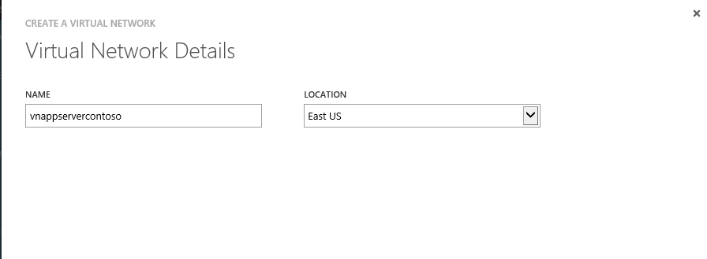

1. On the **DNS Servers and VPN Connectivity** page, don’t make any changes. Just move forward to the next page by clicking the arrow. By default, Azure provides basic name resolution for your virtual network. It’s possible that your name resolution requirements are more complex than can be handled by the basic Azure name resolution. In that case, you may later want to add a virtual machine running DNS to your virtual network.
2. The **Virtual Network Address Spaces** page is where you enter the address space that you want to use for this VNet.
3. Create the following subnets:

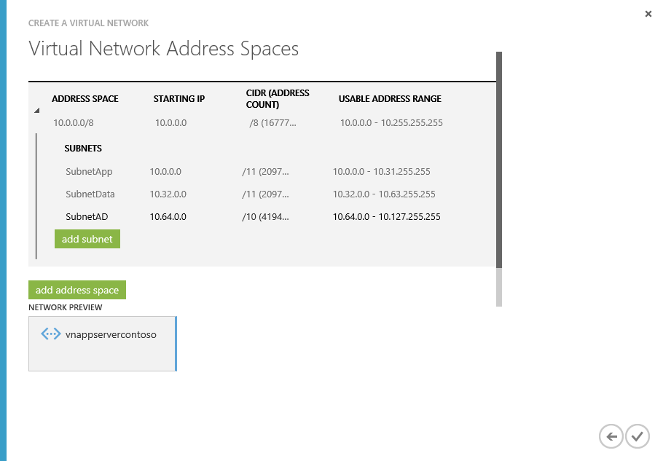

1. Click the checkmark on the lower right of the Virtual Network Address Spaces page and your virtual network will begin to create. When your virtual network has been created, you will see **Created** listed under **Status** on the **networks** page in the Management Portal.

### Exercise 2: Creating the Storage Account

* 1. In this exercise, you will learn how to create a Storage Account.

1. Log in to the **Microsoft Azure Management Portal**.
2. Click Create New, click Storage, and then click Quick Create.
3. In URL, enter a subdomain name to use in the storage account URL.
4. In Region, select a region for the storage. For this exercise select the previously created.
5. If you have more than one Azure subscription, then the Subscription field is displayed. In Subscription, enter the Azure subscription that you want to use the storage account with. You can create up to five storage accounts for a subscription.
6. In Replication, select the level of replication that you desire for your storage account. For this exercise, select Locally Redundant. *Locally redundant storage (LRS)* maintains three copies of your data. LRS is replicated three times within a single facility in a single region.
7. Your storage account should be similar to:
   1. 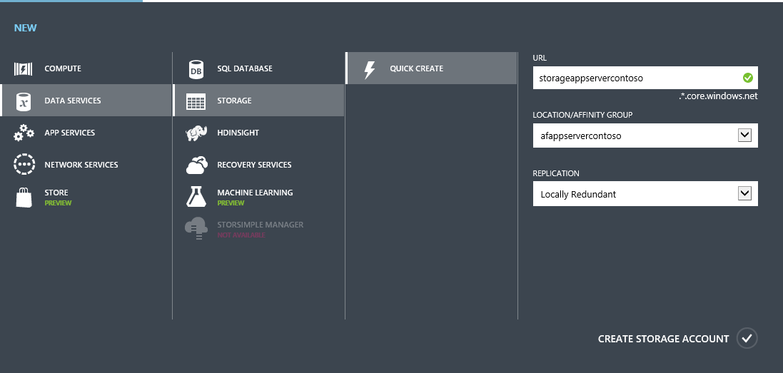

### Exercise 3: Create Remote App Hybrid Collections

There are two kinds of Azure RemoteApp collections:

* Cloud: resides completely in Azure. You can choose to save all data in the cloud (so a cloud-only collection) or to connect your collection to a VNET and save data there.
* Hybrid: includes a virtual network for on-premises access - this requires the use of Azure AD and an on-premises Active Directory environment.

This tutorial walks you through the process of creating a hybrid collection. There are eight steps:

1. Decide what [image](https://azure.microsoft.com/en-us/documentation/articles/remoteapp-imageoptions/) to use for your collection. You can create a custom image or use one of the Microsoft images included with your subscription.
2. Set up your virtual network. Check out the [VNET planning](https://azure.microsoft.com/en-us/documentation/articles/remoteapp-planvnet/) and [sizing](https://azure.microsoft.com/en-us/documentation/articles/remoteapp-vnetsizing/) information.
3. Create a collection.
4. Join your collection to your local domain.
5. Add a template image to your collection.
6. Configure directory synchronization. Azure RemoteApp requires that you integrate with Azure Active Directory by either 1) configuring Azure Active Directory Sync with the Password Sync option, or 2) configuring Azure Active Directory Sync without the Password Sync option but using a domain that is federated to AD FS. Check out the [configuration info for Active Directory with RemoteApp](https://azure.microsoft.com/en-us/documentation/articles/remoteapp-ad/).
7. Publish RemoteApp apps.
8. Configure user access.

Note: Make sure your use the VNET and storage account created in the previous steps.

**Scenario**: [How to create a hybrid collection for Azure RemoteApp](https://azure.microsoft.com/en-us/documentation/articles/remoteapp-create-hybrid-deployment/#step-2-create-an-azure-remoteapp-collection)

### Exercise 4: Creating SQL Server Farm

1. Follow this article, which explores a SQL Server high availability and disaster recovery scenario with SQL Server Database Mirroring configured across two different Microsoft Azure datacenters.
2. Notes:

* Make sure your use the VNET and storage account created in the previous steps.
* In addition, make sure the Database Connection String in the Remote App published application in pointing to this Server,
* This scenario used Database Mirroring for cost purposes, moving forward, Microsoft recommendation is to leverage SQL Server Always On

1. **Scenario**: [Configuring database mirroring in Microsoft Azure](http://blogs.technet.com/b/francesco_diaz/archive/2014/02/05/configuring-database-mirroring-across-two-windows-azure-datacenters.aspx)

## Summary

In this hands-on Lab, you have learnt how to deploy a simple Remote App Hybrid Collection Environment connected to a SQL Server high availability and disaster recovery scenario with SQL Server Database Mirroring configured in Microsoft Azure datacenters.